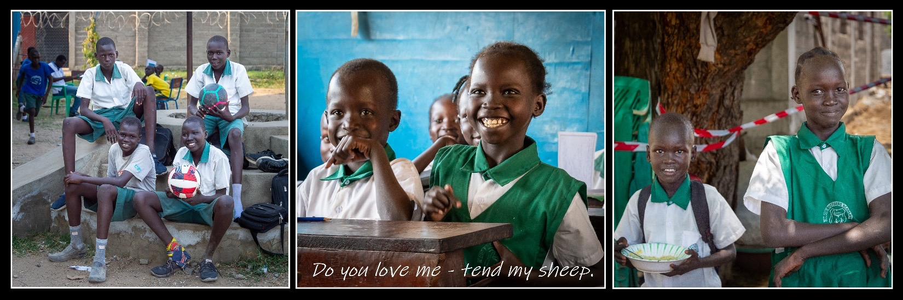

**Locking Arms – Fellowship and Dinner Event**

**The Good Shepherd Academy**

Date: March 12th, 2025

Time: 6:30 PM to 9:00 PM

Place: Valley Brook Country Club,

425 Hidden Valley Road - McMurray, PA 15317

Please join us for this special get together - a time of celebration and prayer, with a special focus on our ministry partnership with the Good Shepherd Academy and the work of Pastor John Chol Daau. We will have an opportunity to hear greetings and an update that Pastor John has prepared for us and hear stories from a few of our brothers who have visited South Sudan and have known him for many years. We will also learn about our vision to help the school create a sports program for the children as well as a possible trip to the school in Juba, South Sudan later this year. Finally, we hope to introduce a few of the students to hear about their lives and see the impact that the ministry is having upon them. We encourage you to bring your friends, your spouse and your family to this important dinner event.

Last year we joined this ministry through prayer and encouragement as well as financially supporting the ongoing operation of the school. We held a successful golf outing that raised over $24,000 including special contributions to cover the cost of uniforms ($100 for a set of 3 uniforms), meals for a year ($75 per child) or annual school fees ($250 per child). We have also supported the ongoing operations of the school through individuals’ faithful, monthly contributions. We are hoping to do even greater things in 2025 as we seek to serve the Lord through these precious little ones that many would count as among the least of these.

The suggested donation for the dinner is $75 per person or $600 per table of 8. In order to help us plan for the meals, please [register here](https://docs.google.com/forms/d/e/1FAIpQLSfmusMWZZBxU6X1iWW6CTfQMWRSm8rLWLVYgN-ItGKQ3Eofvg/viewform?usp=header) with online payments, or send checks payable to GSEF and mailed to GSEF co/Josh Patterson – 6954 Sisto Street, Verona PA 15147. To learn more about the Good Shepherd Academy visit [www.GS-EF.org](http://www.GS-EF.org), hear Pastor John’s story [in this video](https://gs-ef.org/gsa-goodness-of-god-2023/) and in his book - [God’s Refugee](https://www.amazon.com/Gods-Refugee-Story-Lost-Pastor/dp/B09RLSWGLV/ref=sr_1_1?crid=Y0TMSQGDQ7RG&keywords=god%2527s+refugee&qid=1685396977&sprefix=god%2527s+refugee%252Caps%252C101&sr=8-1). We are looking forward to seeing you there as we seek to serve our Lord together – both near and far. Recall the words Jesus; “As the Father sent me, so I am sending you.”

Locking Arms Men  
GSEF  
 Love God, Love Your Neighbor 921 Bashford Lane

Make Disciples Alexandria, VA 22314

[www.lockingarmsmen.org](http://www.lockingarmsmen.org) [www.GS-EF.org](http://www.GS-EF.org)